docker login

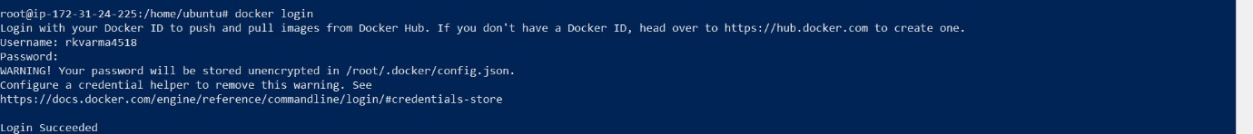

docker pull hello-world

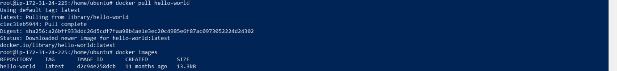

docker tag hello-world:latest rkvarma4518/rahul-hello-world:v1

docker push rkvarma4518/rahul-hello-world:v1

